1. Baudu Security Response Center (BSRC) - The misalignment of Baidu Mini Program API-Scope leads to permission escalation and information leakage - **High Risk**

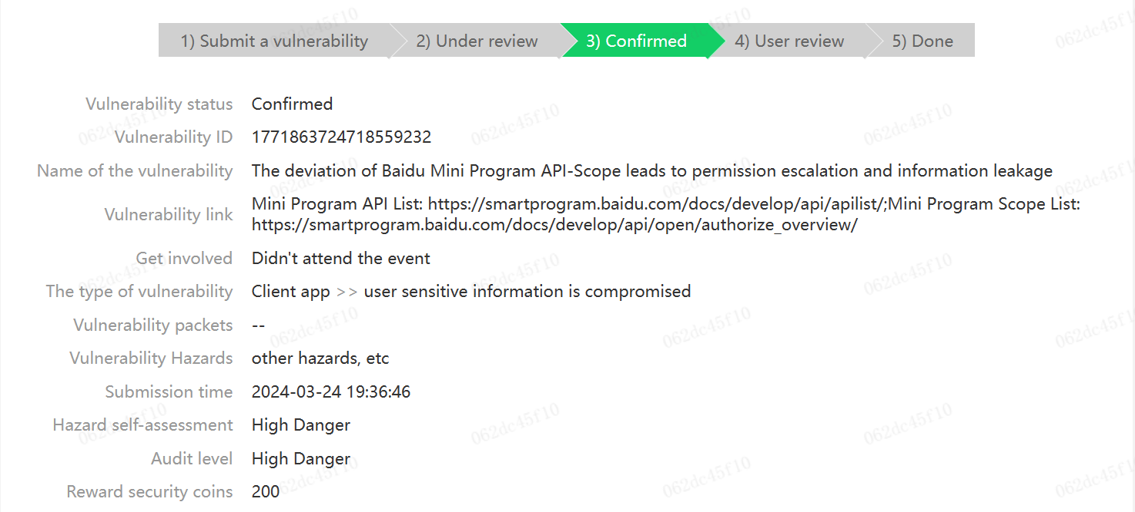

1. Tencent Security Response Center (TSRC) - The misalignment of the API-Scope of the WeChat MiniProgram leads to the escalation of permissions andinformation leakage – **Medium Risk** (Contribution value: 175, Business attribution: core business)

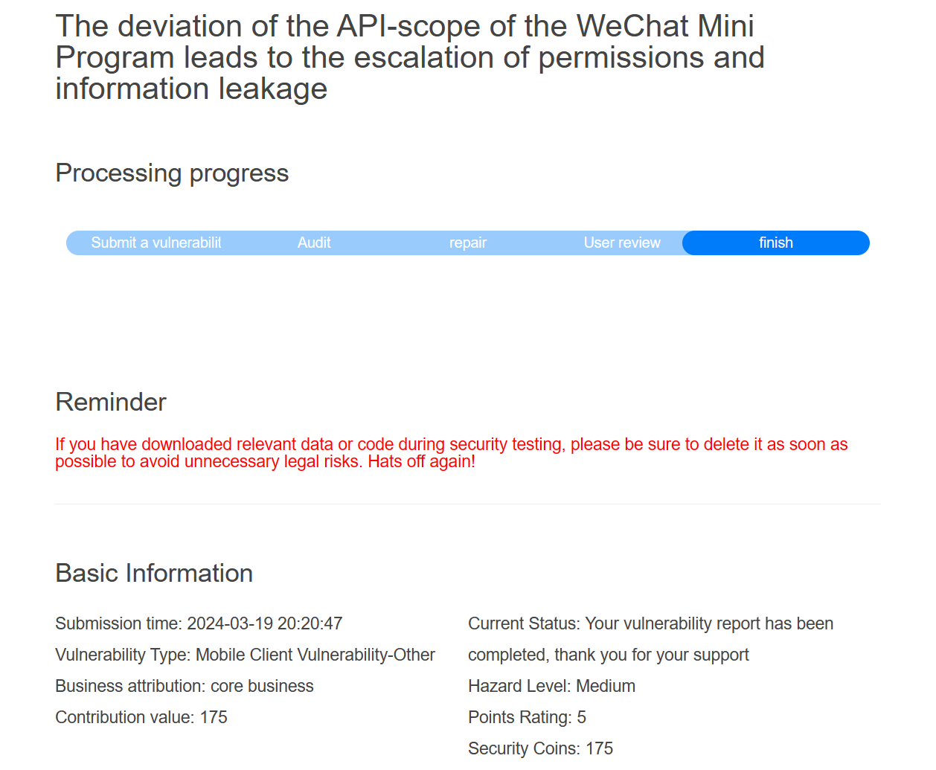

1. Tencent Security Response Center (TSRC) - QQ Mini Program camera album APl permission defect - **Medium Risk**

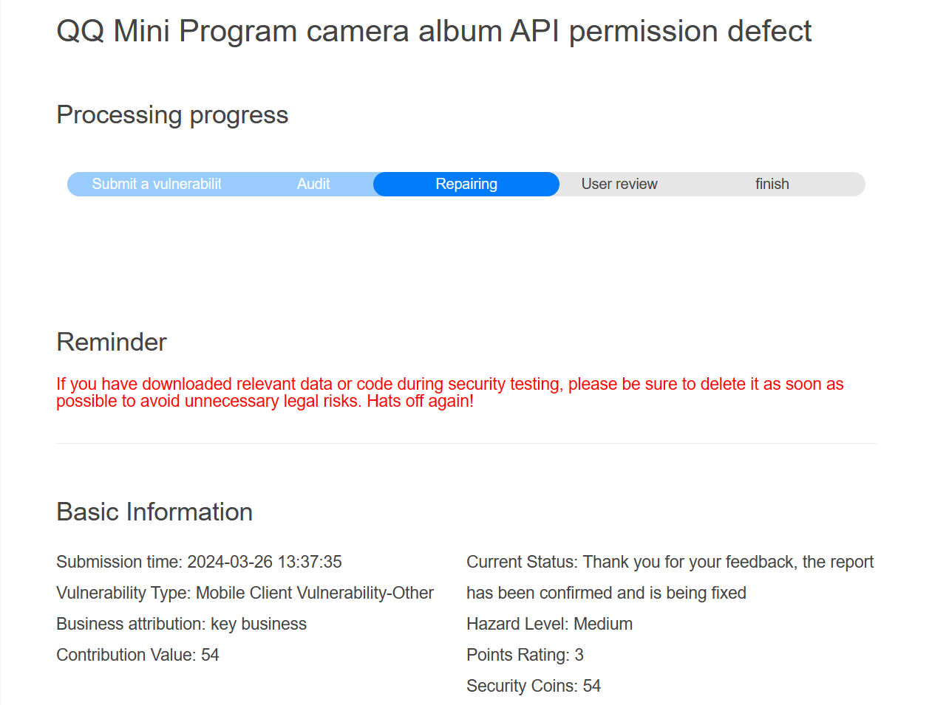

1. ByteDance Security Response Center (ByteSRC) - The multi-permission APl parameter vulnerability of Byte Mini Program leads to permission escalation and information leakage – **Low Risk**

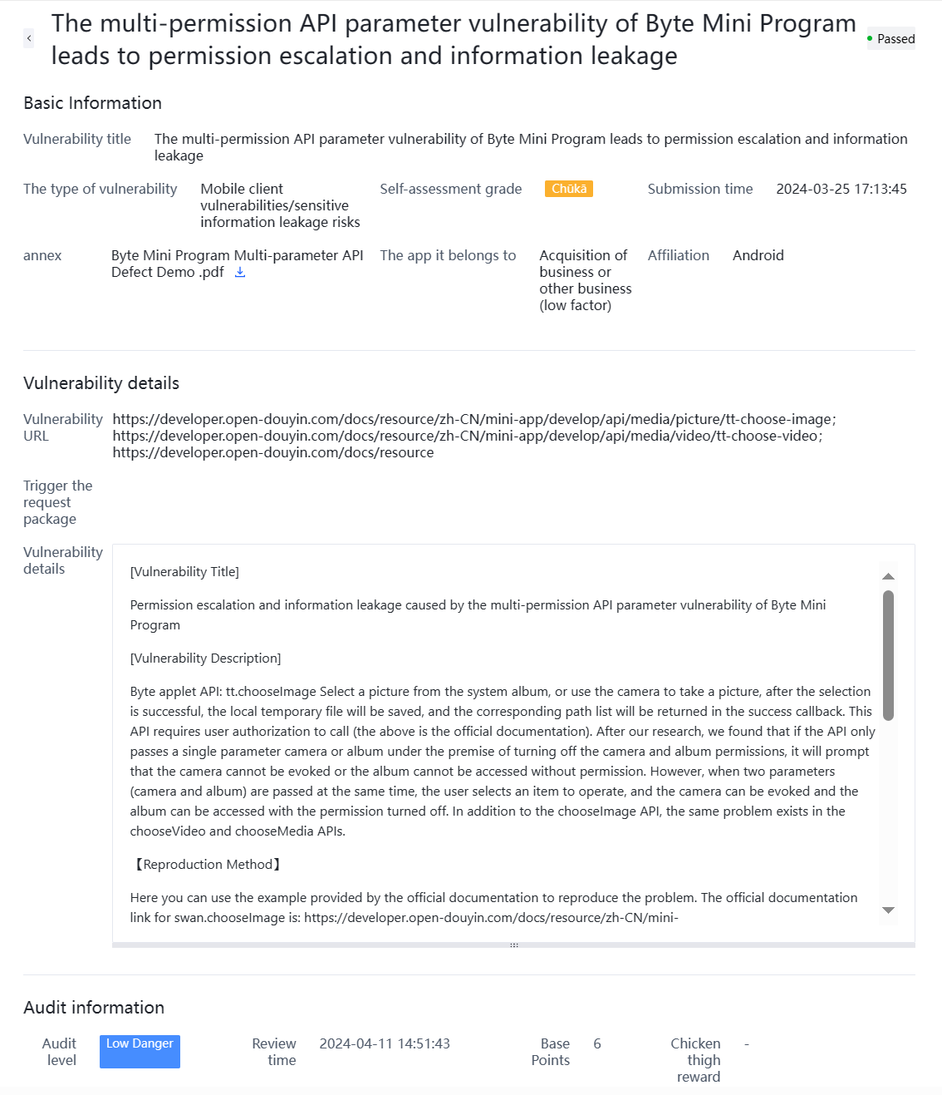

1. China National Vulnerability Database (CNVD) - There is an information leakage vulnerability in theswan.getClipboardData API of Baidu Smart Mini Program - **Medium Risk (CNVD-2024-15202)**

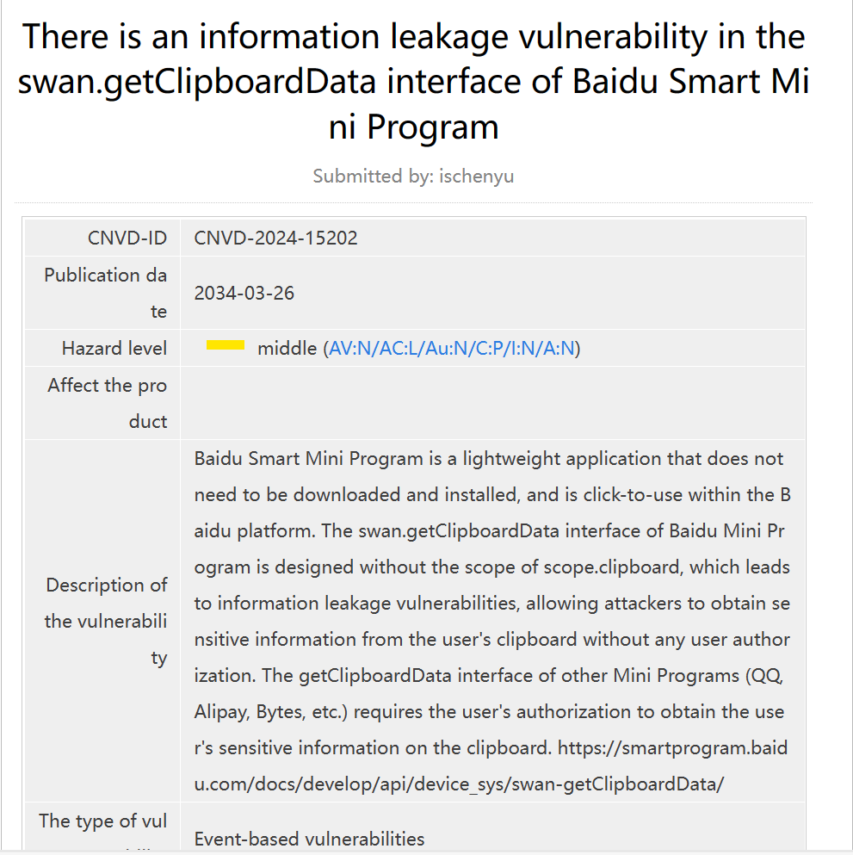

1. China National Vulnerability Database (CNVD) - There is an unauthorized access vulnerability in the camera album APIs of WeChat Mini Program - **Medium Risk (CNVD-2024-17003)**

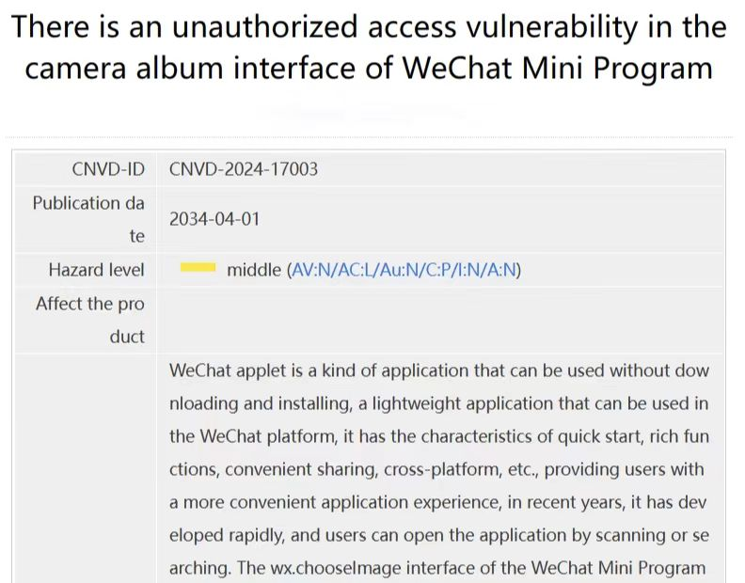

1. WeChat Support - Feedback on security vulnerabilities in WeChat Mini Programs – **Positive confirmation**

